Lightweight Phishing Detection
What to prepare:
- Environment
  - Python
  - VS Code
  - Pandas, numpy, scikit-learn
  - Matplotlib
  - PyTorch
  - Tqdm
  - Joblib
- Dataset
  - Main dataset: Kaggle phishing URL dataset
  - External test data: PhiUSIIL
- Cleaning and cutting rules
  - Remove null values
  - Remove duplicate URLs
  - Unify labels to 0/1
  - Train 70% / val 15% / test 15% stratified split
  - External set not participating in training, only for test generalisation
- Baseline Feature Table
  - URL length
  - Domain length
  - Path length
  - Digit count
  - Special character count
  - Dot count
  - Hyphen count
  - Subdomain count
  - Does it include IP address?
  - Does it include “@”?
  - Does it use HTTPS?
  - Number of suspicious tokens
- TCN Input Format
  - Character vocabulary
  - Max URL length
  - Padding / truncation
  - Label tensor
- Evaluation record template
  - Model name
  - Dataset scope
  - Accuracy
  - Precision
  - Recall
  - F1
  - AUC
  - Training time
  - Testing time
  - Per-sample latency
  - TES
  - IES
  - RTDE
Phase 1: Get the data pipeline running
Objective: Prove the data can be read, cleaned, split it, and output it in a trainable format.
- Read 2 datasets
- Check field name
- Clean malformed URL
- Deduplication
- Output train / val / test
- Output external test
- Do class distribution checking

Phase 2: Make a baseline
Objective: To have a model that can be trained, predicted, and evaluated.
- lexical feature extraction
  - 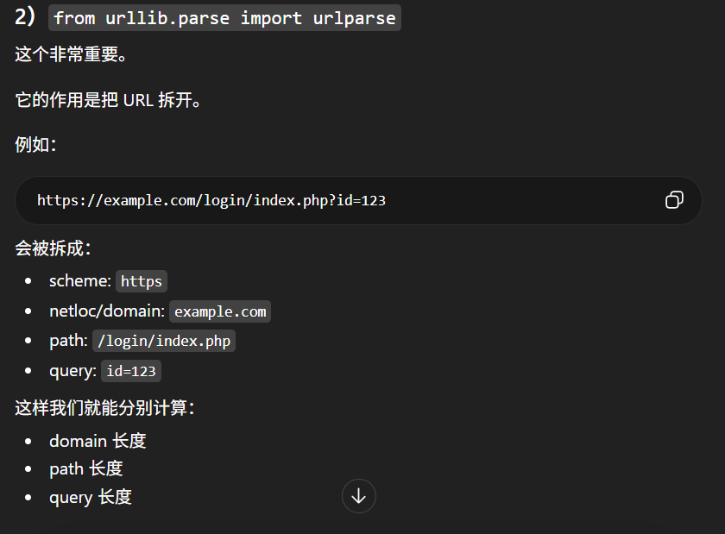
- Random Forest training
  - X = Input features seen by the model
  - Y = Correct answer: label
  - 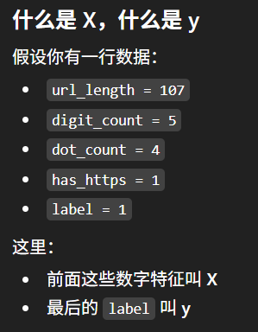
- internal test evaluation
- external dataset evaluation
- latency measurement

Phase 3: Make smallest version of TCN
Objective: To first create a TCN URL classifier without overly complex mechanisms.
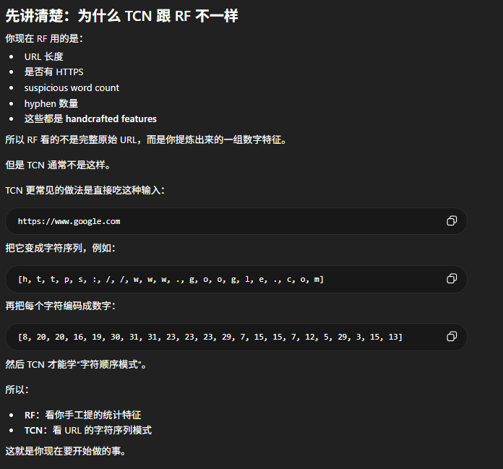
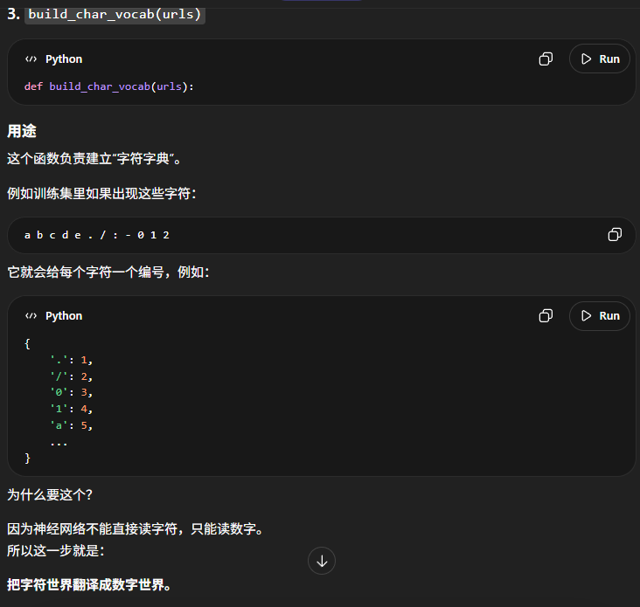
First version only need:
- char embedding
- 1–3 layer TCN block
- Global pooling
- Linear output
First confirm:
- The loss will decrease
- The value and F1 score won’t fluctuate wildly
- Influence can run
- CPU can measure latency

Phase 4: Add attention
Objective: Make sure the target report method matches the report

Phase 5: Do a lightweight evaluation
Objective: Start showcasing the unique features of the project, rather than just reporting accuracy.
- TES = Accuracy / Training Time
- IES = Accuracy / Testing Time
- RTDE = Accuracy / Per-sample Detection Time
Comparisons were made using the same machine, the same batch of data, and the same testing procedure:
- RF baseline
- TCN
- TCN + attention

Phase 6: Do threshold and explanation
Objective: Integrate the model results into the system logic.
The system doesn't just output phishing / benign in the report, but rather:
- Safe
- Suspicious
- Phishing. Also includes a risk score, a brief explanation, and an awareness tip
Also need to add the following later:
- Score risk level mapping
- Explanation rule templates
- Tip templates

Cannot use PhiUSIIL datasert cuz overlap with Kaggle dataset

In this dataset, the presence of HTTPS appeared to be a strong discriminative feature. However, HTTPS alone should not be interpreted as a guarantee of legitimacy, since phishing websites may also use HTTPS. (from analyze_rf.py)

Enter URL Extract Features Model Prediction Output Risk Results

Test URL
https://www.google.com (benign)
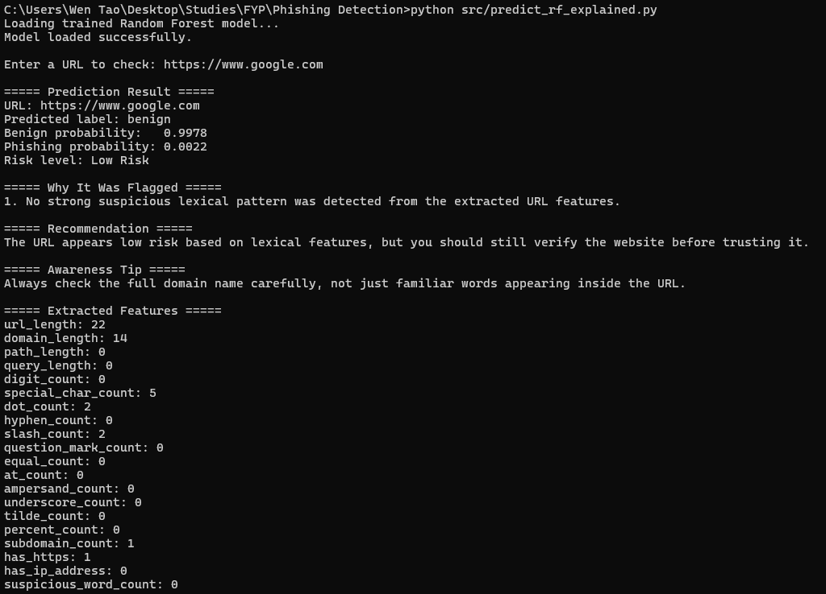
http://secure-paypal-login-verification.com/account/verify (phishing)
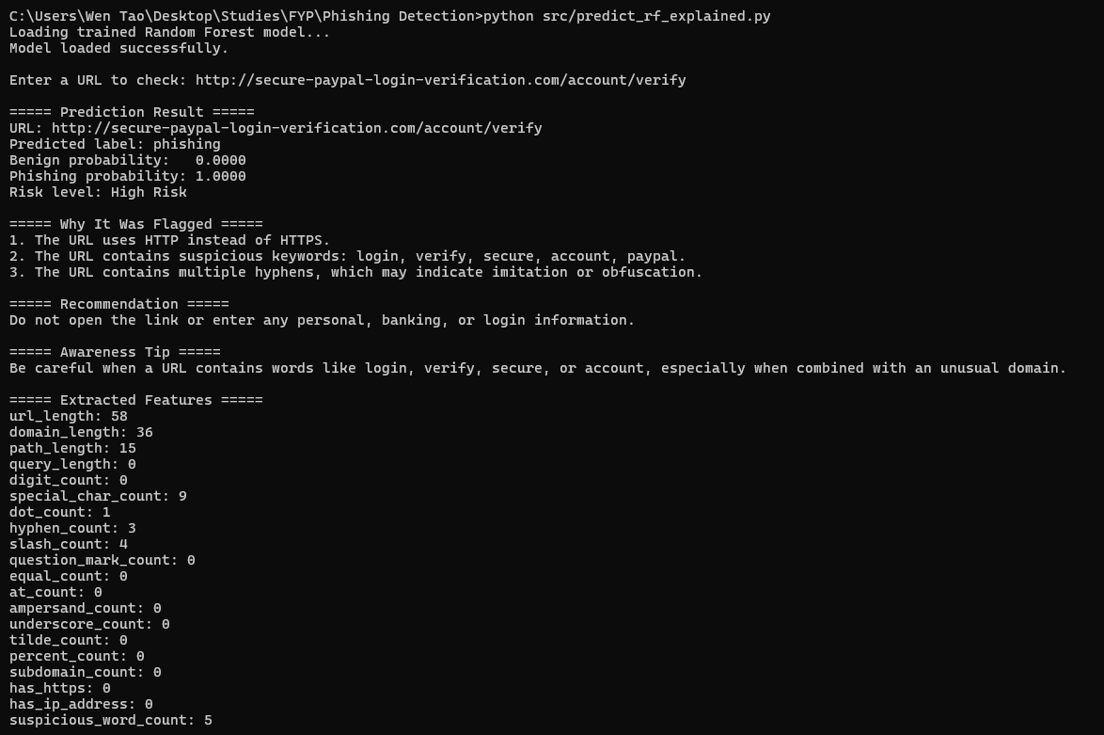
RF can capture suspicious lexical patterns, but some cases may remain borderline and require careful interpretation.

https://update-service-login.example.org (suspicious)
